**Workshop on Business model canvas**

**On 31st May 2022, 10 AM to 4 PM**

**Speaker: Ajay basil Varghese**

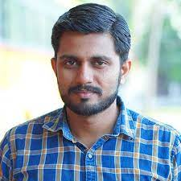

Mr.Ajay Basil Varghese is an Academician and an Entrepreneur with over 10 years of experience in initiating and building successful businesses working as a startup Coach , KDISC mentor & incubation manager at Adi Shankara TBI , Kalady.

Completed his PG in Computer Science and Engineering from Anna University , Chennai and started his career as an assistant professor at Adi Shankara Institute of Engineering and Technology from 2012. He has over a decade of experience in teaching and mentoring students. Started his first software development venture named Vooxo Labs in 2015 and kick started the entrepreneurial journey.

Date: 31/6/2022

Time : 10 AM to 4 PM

Duration : 6 hours

Platform: Ramanujan Hall (ECE block)

No of Attendees:

Students:

Faculty: 3

**Report**

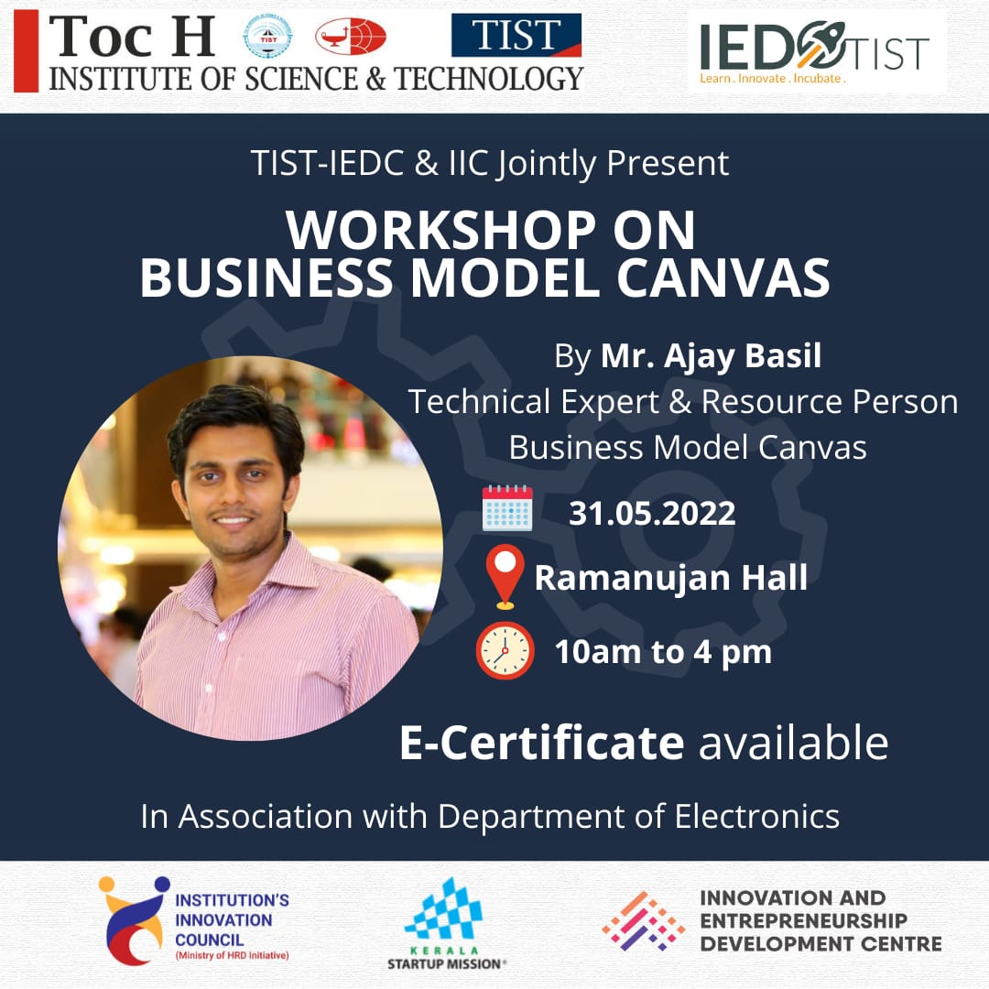

The workshop on Business canvas model was conducted by Toc H institute of science and technology in association with IEDC cell of TIST on 31st May, 2022 from 10 AM to 4 PM. The workshop revolved around introducing the theme of innovation which is to “Break, Innovate and Rebuild”

The session highlighted the importance of team building with all categories of people and shared real-life stories of successful business and innovation model teams. Mr Ajay basil sir shared about his journey as an investor in startup and about his own startups which was a great motivation to the students.

He also shared about the importance of patents and how to generate a recurring income with an innovative idea. He showed the steps for filing a patent and how to check if your idea is a patent eligible idea. The life story of Aishwarya Paramadathil (Machine for disposing off sanitary napkins) has helped the students in understanding more on the value of innovative idea and constant passion.

The session was highly motivational and fun. The students were much eager to enjoy and participate in the event because of the group activity to make their own business canvas model. He advised all students to come out of the inertia state and bring out the talent. The workshop concluded by sharing the opportunities and financial assistance provided by the government to help students in startups.

The session was attended by ----- participants and it lasted six hours.